Art Reflection
Throughout or during this unit there were many things we learned, either from research or from experiencing it. At the start of the unit the word figure drawing did not ring any bells for me, it was unfamiliar. I could only make out that it would be drawing figures, by looking at the word. However through research and by drawing figures I learned that there were way more to it than just drawing figures. There was life drawing, which was drawing from life, we needed to think about proportion, as well as the fore shortening. However my learning did not stop, I learned about the art, along with myself as a student. I learned that I was good at capturing the basic outline figure of the model; however I was bad with the proportion. Usually my lower body proportions were out of the normal, compared to my drawings of the upper body.
This unit allowed me to improve my skills further. The timed life drawing really helped improve my skills a lot. This was because I needed to draw the figure in a specific amount of time, the pressure was really great, and so for the time limits like 1 minute, we had to think what important features should be included.
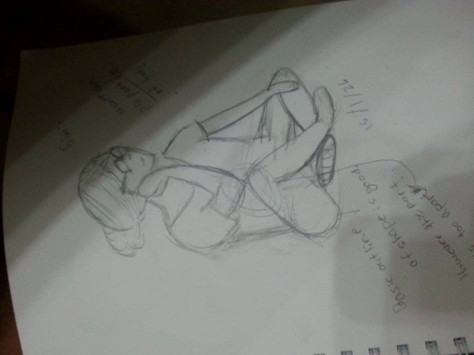
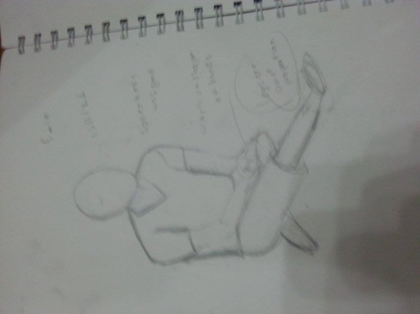
Looking at all my life drawings that I did in this unit, my drawings have changed and progressed. On the left is my earlier life drawing of Koki. The time given was 5 minutes, the good part was that his upper body was in shape, and the pose he was in was recognizable however the foreshortening and the proportion of the legs was a bit off. Then the next one was another 5 minute drawing, which is on the right. In this drawing the pose was not as perfect as before however, facial features and hair detail could be drawn, this shows that I was able to draw more in 5 minutes compared to before, however again, proportion and foreshortening is not great.

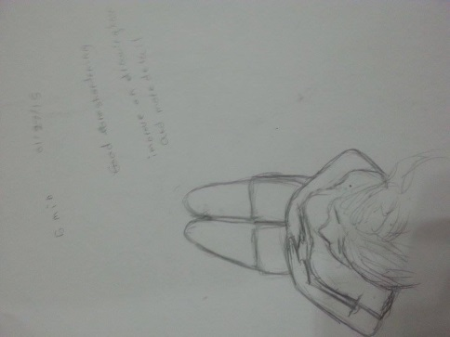
Last drawing was:

This was a drawing of lingling laid down on the table. Her head top was facing me and she had her arms on top of her stomach. This was nearly at the end of the unit. As you can see there was crazy foreshortening however I managed to draw it with the foreshortening, this is a great achievement for me, since I was bad with foreshortening at the start of the unit. The proportion was also improved compared to my past drawings. However it would have been even better with detail in the hair.
If someone was considering trying figure drawing I would give them some advice that I think is essential for the success of the drawing. If the life drawing is a portrait of someone else, I would recommend them/that person to look for distinctive features, the face shape, and the shadows on the face. Focus on where the light is coming from in order to shade in better shadows. Normally ear is about side of the eye to end of nose, nose width is width of an eye, and the space between the eyes should be able to fit one eye. If for a figure, then it would be first capture the basic shape, then foreshortening, after that add details of the face ( if needed), and add details such as shadow.

In the process of finishing my final piece I have received feedbacks while working such as I should use reference photos for drawing my final piece and using Photoshop make it black and white in order to make it easier to see the shadows. At first I only had one photo however I received advice that if I am going to draw the hand for the “puppet master”, I should take a photo of it as well. So I ended up with two reference photos for my piece.
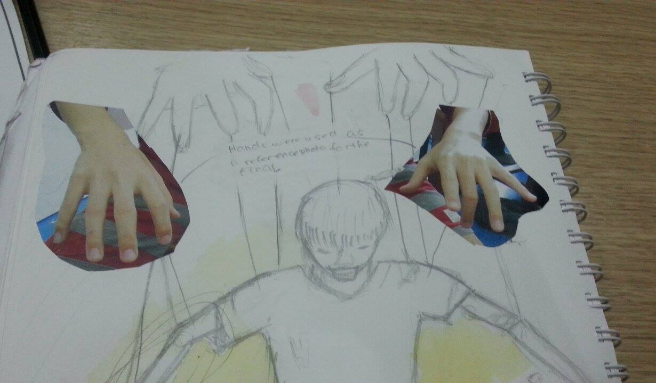
Reference photo #1
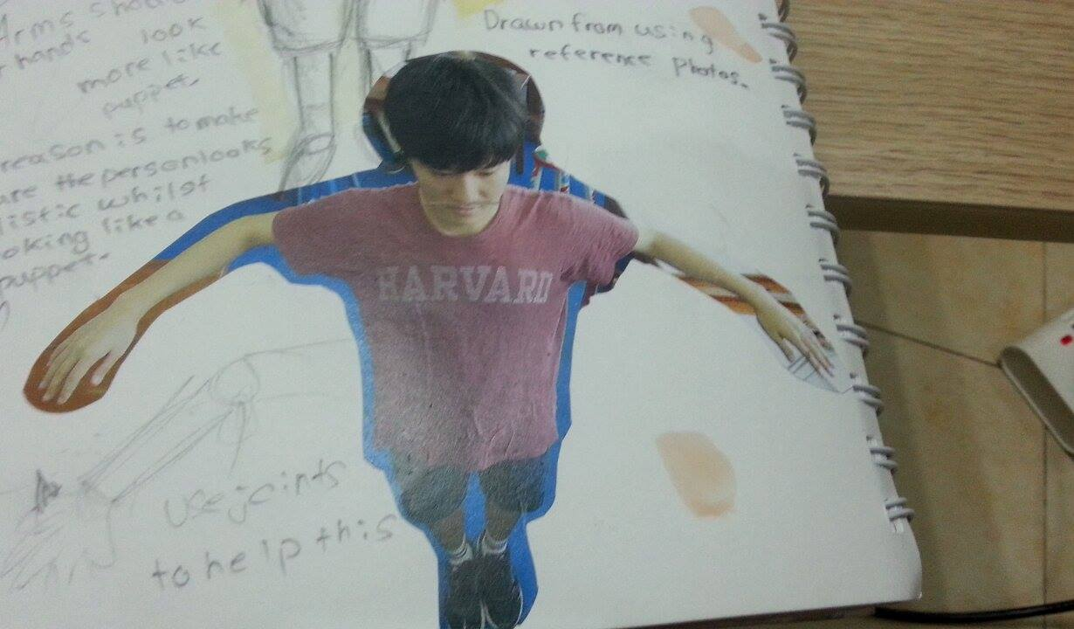
Reference photo # 2

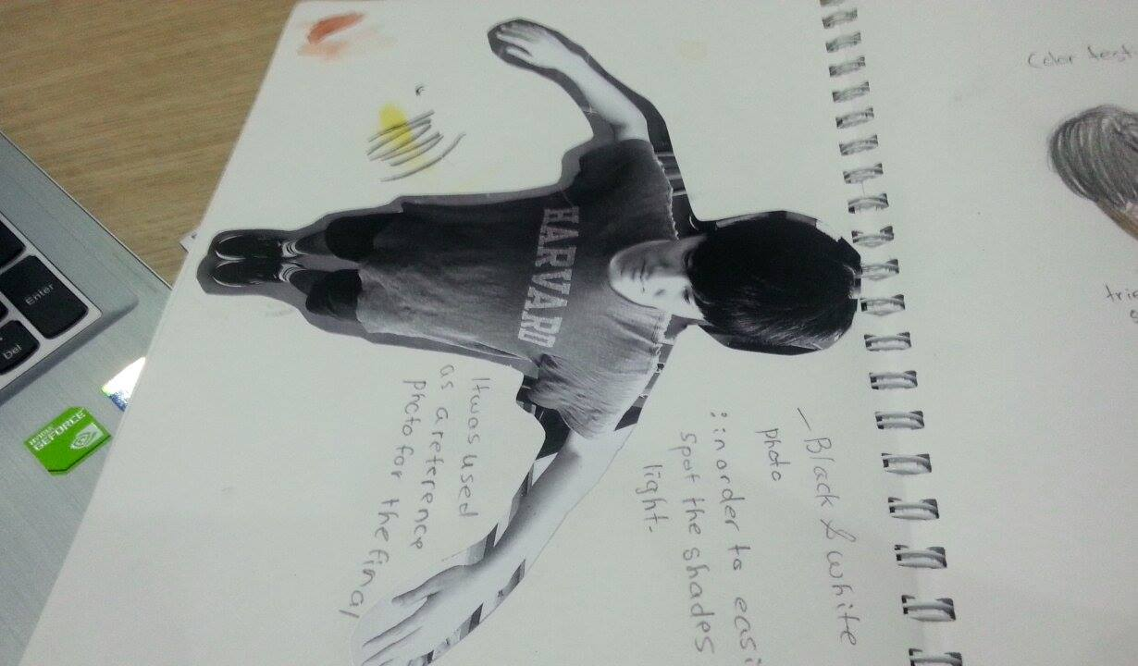
Black and white image of Reference photo # 2

These feedbacks helped me a lot and by following the feedback I was able shade in detailed shadows, as well as a realistic controlling hand.
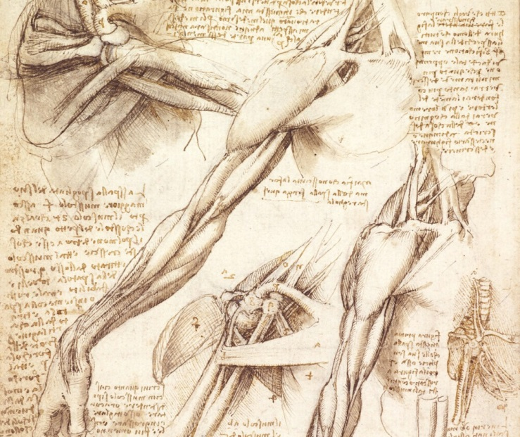
From experiencing the two life drawing and drawing from a photograph, I prefer drawing from a photograph. First of all, personally drawing from a photo was easier for me, and by capturing the figure in a photo I was able to draw the precise shadow and posture. However when I did the life drawing the model kept changing facial expressions and shadows kept on changing along with the movement of the model, which was very annoying.
Knowing anatomy helps with figure drawing a lot, the body proportion can be drawn well if you know the anatomy well. You will be able to see which part is which part of the bone and muscle. The famous case is Leonardo da Vinci did when he studied the human anatomy.
https://www.pinterest.com/jasonandrewreid/leonardo-da-vinci-medical-drawings/
Final Outcome
I believe the strengths of my figure drawing are capturing the pose of the model well. It is easily visible what pose the model was in when I took the photo. Another strength is my shading, because I took in the advice, I was able to get proper shading into my drawing.
Although I have tried my best on this drawing, there are still some parts that can be improved on. On the left arm of the puppet like man, I made a little mistake with the shading, so it does not look too smooth. If you look closely there are some paint marks below the black, the paint ran down the page. Another thing that I could improve is that compared to the original image (reference photo # 2 ) the painting had a little bit of different foreshortening. The reference image is taken from a higher angle than the angle painting/drawing is representing. So next time I do this I want to be more careful with my brush strokes and maybe draw shades with lighter color pencil (HB), in order to minimize mistakes. For foreshortening, I think the head top should have been showing more, in order to make it look like the reference photo.

Overall I am satisfied with my final outcome, and it was an interesting unit with lots of learning.

